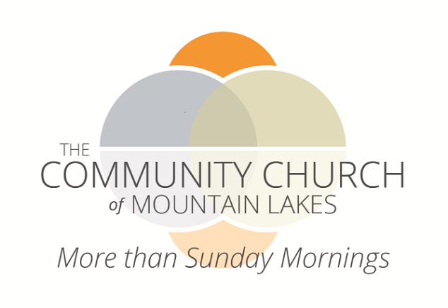

Director of Music

Job Summary:
The primary focus of this position will be leading the Music Ministry of the congregation. This will include being a key member of the Worship leadership team, providing musical leadership broadly, and creatively expanding upon the church's musical heritage with an eye to keeping it both faithful and relevant. The church has a Casavant-Freres pipe organ, digitally enhanced with Ahlborn-Galanti electronic voices and a Steinway grand piano in the Sanctuary as well as 3 octaves of Whitechapel handbells. The position is part-time with total hours averaging 20 hours or less per week, only a portion of which will the Director of Music need to be on-site. The position reports to the Senior Pastor.

Essential Functions:
- Working collaboratively with the Senior Pastor and other staff, plan and lead a Music Ministry that is integral to the life of the congregation, enhances our Worship life and enriches other programs and ministries of the church.
- Serve as organist/pianist at our 10:00 am Worship Celebration on Sunday mornings and at other seasonal or special Worships; have the right of first refusal for playing for all weddings and funerals/memorials.
- Lead the Chancel Choir, seeking creative ways to enable busy volunteers to participate and nurturing the singer’s growth as musicians.
- Direct the handbell and chime choir(s), providing appropriate instruction and guidance that enables both those with musical training and those without musical training to participate and to grow as musicians.
- Coordinate, schedule and rehearse soloists or small ensembles, for special occasions during the year as well as for special music during the summer.
- Participate in Staff meetings and Worship Team meetings as requested.

Secondary Functions:
- Arrange for a substitute organist/pianist (and choir director, if needed) whenever the Director of Music will be absent.
- Actively identify and encourage the musical talents of the congregation.
- Lead the music program for children and youth with an eye toward expanding participants’ knowledge and love of music, as well as the joy of participating in Worship leadership.
- Work in collaboration with other staff and Worship leaders to prepare and run the audio/visual and digital equipment used in Worship.
- Collaborate with the Senior Pastor to ensure that all copyright laws and licensing requirements are followed.
- Work with other staff, to develop and advertise musical programs that are accessible to those outside of the congregation as part of our broader effort to engage our community and to be The Community Church, inviting and welcoming all.
- Oversee the use and maintenance of the organs, pianos and other musical properties of the church, making arrangements for maintenance, repair and tuning after obtaining authorization for such from the Pastor and/or the Board of Trustees.

Main Core Competencies:
- Talented Church Musician - employs training and experience to provide a faithful and meaningful Music Ministry.
- Broad Musical Footing - understands, values and incorporates a wide range of musical expression, (choral, solo, and instrumental), utilizing traditional, global and contemporary idioms, seeking always to ensure that the music fits with the church's vision and theology.
- Mission Ownership – demonstrates understanding and full support of the mission, vision, values and beliefs of CCML and the UCC; can teach those values to others; leads others in owning the same; lived commitment to inclusivity in all ways (age, race, gender, economic, social, ethnic, etc.).
- Interpersonal Skills – demonstrates the ability to work with different kinds of people, negotiating the relationships professionally and lovingly while holding people accountable; productively engages and resolves interpersonal conflict; respects appropriate boundaries; demonstrates active listening and openly accepts criticism.
- Emotional Maturity and Experience – possesses the emotional maturity that comes from self-reflection and work and thus is able to be supportive of others.
- Self-motivated and Accountable – demonstrates initiative and creativity in one’s ministry balanced with accountability; understands what the position requires and does it without prodding but also seeks guidance and feedback from supervisor and church leadership.
- Professional – demonstrates appropriate professional behavior, especially in the areas of public performance, professional boundaries and confidentiality.
- Motivator – able to engender interest and commitment in others. Gifted in generating enthusiasm and in developing volunteers and program participants.
- Team Player – commitment to working collegially with different types of people, members and staff, for the good of the church’s ministry.

Other Desired Qualifications:
- Educational degree(s) in relevant field(s) of music.
- Experience as a Director of Music in a church setting.
- Must pass a background check.

Remuneration:
- This part-time position starts in the $23,000-$25,000 range. Starting offer dependent on experience and talent.

About Us:
The Community Church of Mountain Lakes is an historic United Church of Christ congregation in verdant Morris County. We are about transforming lives and transforming the world in which we live. We start with inspiring worship on Sunday morning and then offer supportive relationships, activities and programs for all ages and all interests, all week long. At CCML there are many reasons to be and stay engaged. CCML is more than Sunday mornings.

Apply with references and resume to The Community Church of Mountain Lakes, 48 Briarcliff Road, Mountain Lakes, NJ 07046 or email to srpastoratCCML@gmail.com.

